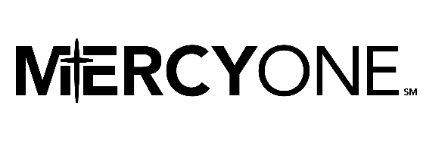
Friends of Cedar Falls Medical Center and Friends of Waterloo Medical Center
Application for Educational Assistance to Pursue a Degree in a Medical Field
All application information is required and confidential.
PERSONAL INFORMATION
1. | Name |  |  |  |  |  |  |  |  | Date
2. | Age | SSN | Email |  |  |  |  |  | Telephone
3. | Address |  |  |  | City |  |  |  | State |  | Zip
4. | High School Attended |  |  |  |  |  |  | City
5. | Year of Graduation |  |  |  |  | Years Attended
6. | College Credits Earned |  | Institution |  |  |  |  |  |  | Date
7. | What is your medical career goal?
8. | Selected Institution or Place of Training
9. | Yearly Cost |  |  | Have you applied? |  |  | Have you been accepted?
10. | Married? |  |  |  |  | Number of Children under Age 18

FINANCIAL INFORMATION
11. | Are you currently employed? | Where?
12. | Spouse employed? | Where?
13. | Have you applied for financial aid?
14. | Will you work while attending college? |  | Are you enrolling full time?
15. | Amount of other scholarships and financial aid you will receive.

Submit photo electronically by email to diane.jorgensen@mercyhealth.com.
Applications and ALL requested information must be in one packet; by mail to MercyOne Waterloo Foundation, 3421 West 9th St., Waterloo and received by midnight, March 6, 2020.

